- Suggestions from AI:
  - 2 AI suggestions you accepted
    - The article card structure includes title, summary, category, and date.
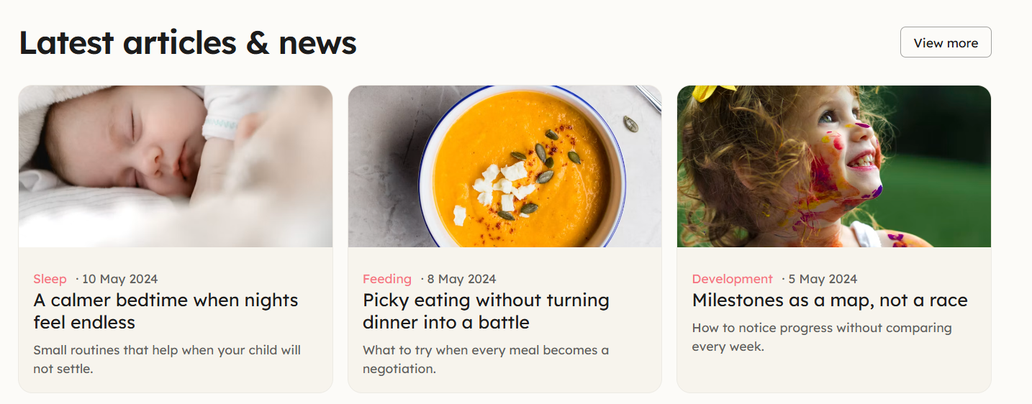

  - 2 AI suggestions you revised
    - Article page: Center the article on the page
Before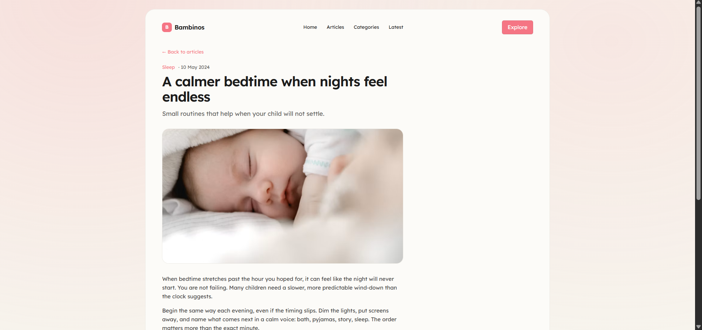
After 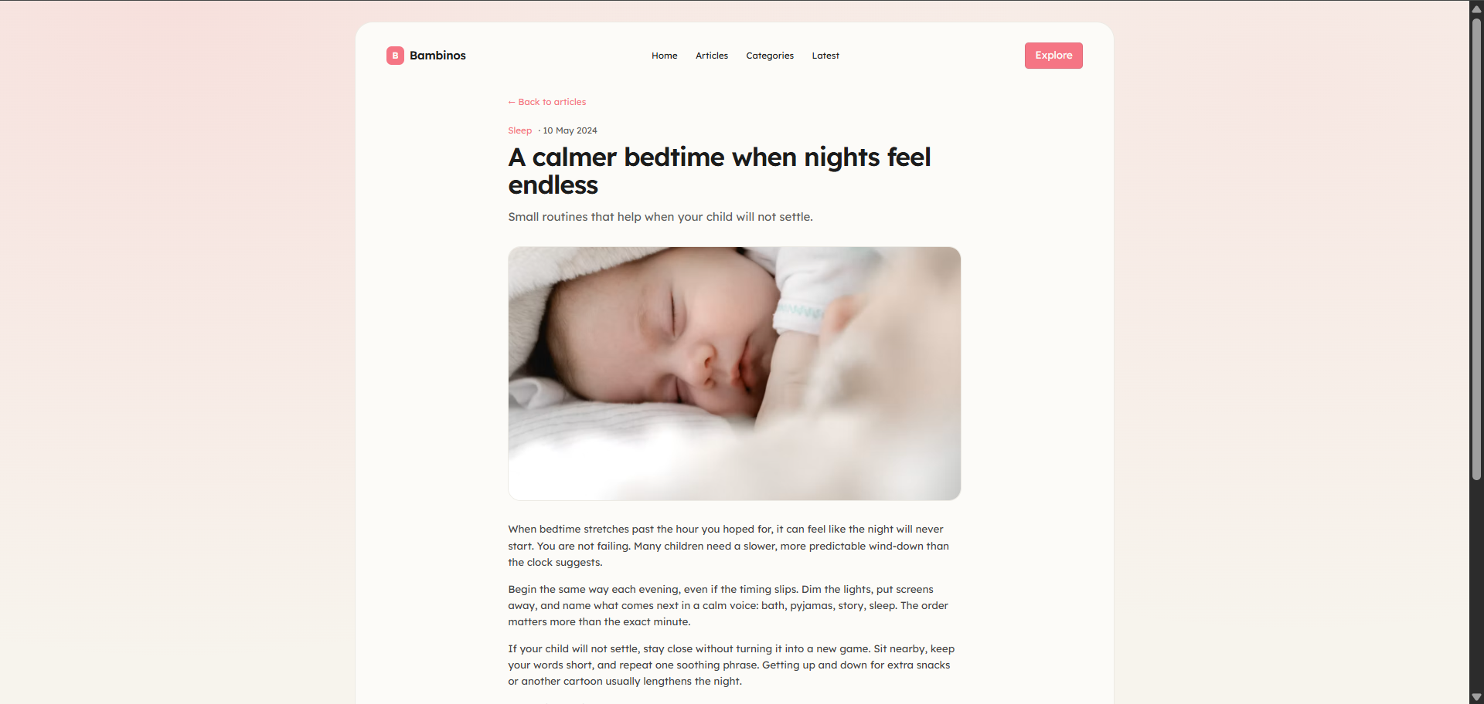

    - Remove the Explore button from the menu and move it into the hero section.
Before 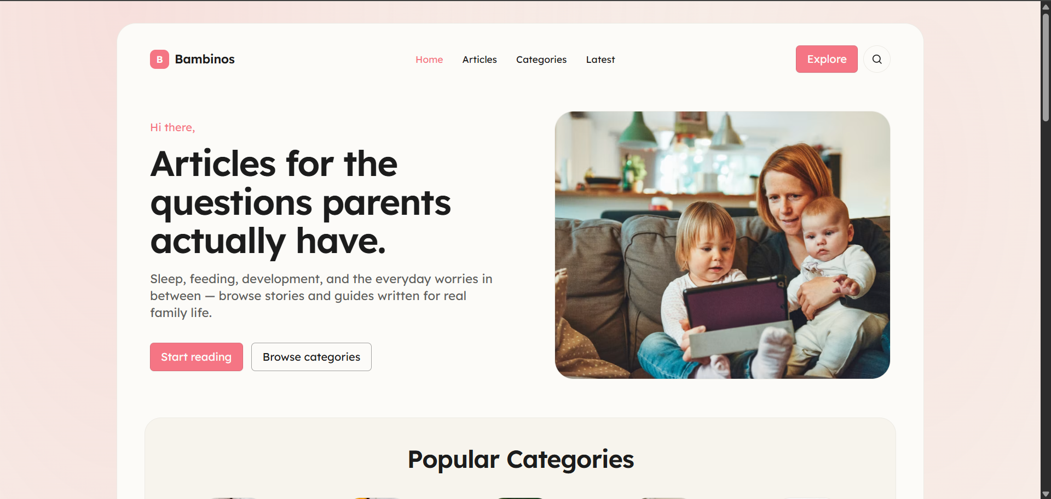
After 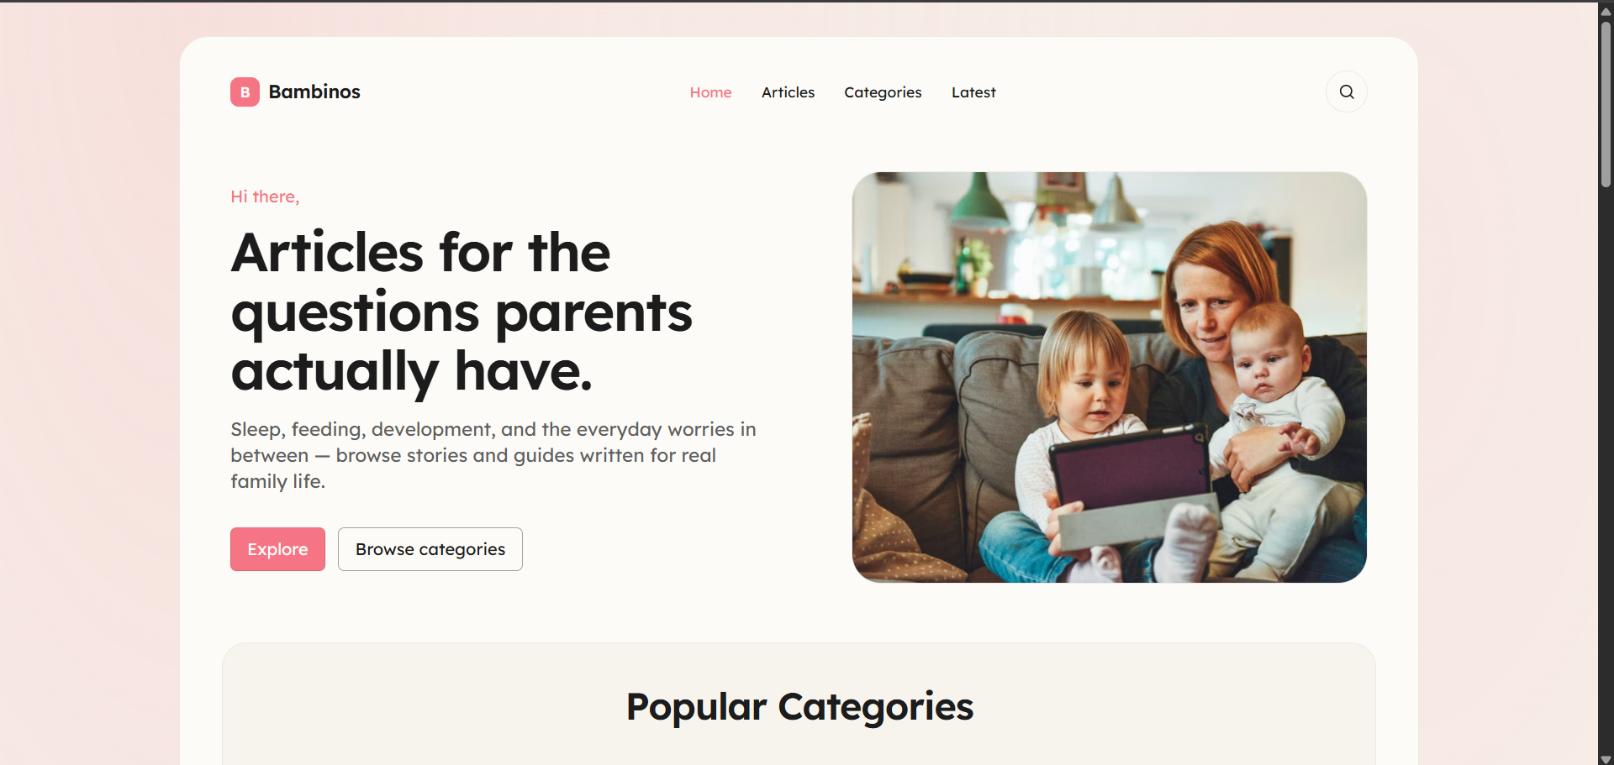
  - 1 AI suggestion you rejected
    - Aligning the sections together results in a mismatch:
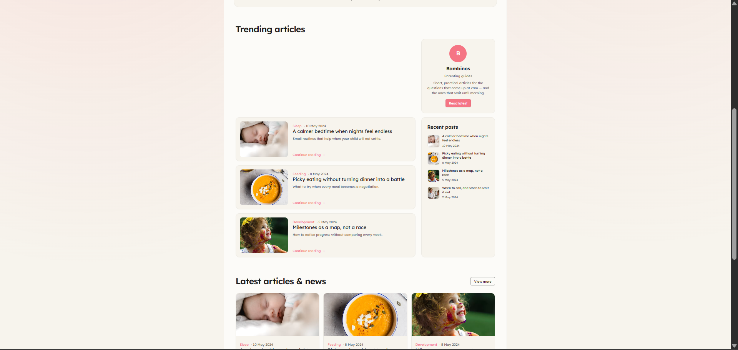
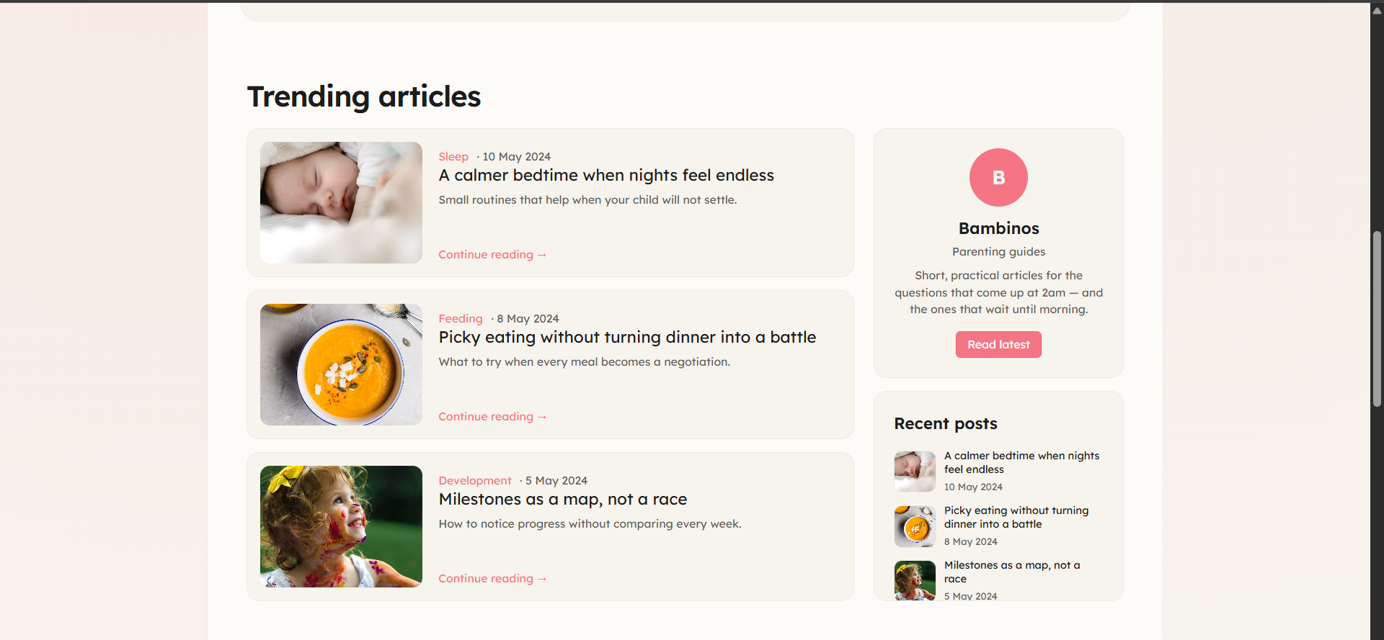

- QA Evidence
  - The article doesn’t have the same sizing:
    - Before
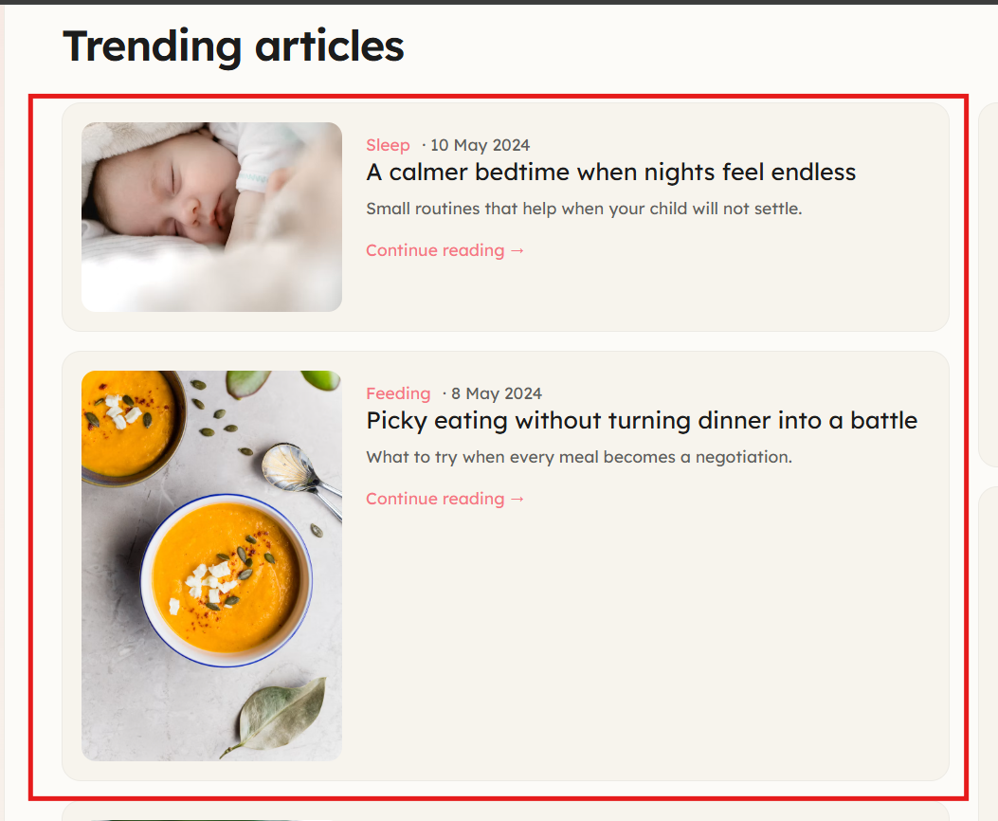
    - After
